## Executive Summary

The question to be answered by this project is as follows: Can a race car be a better investment than just saving my money? In this analysis we will use initial cost, operating costs, maintenance costs, and the salvage cost to calculate the total rate of return, which will then show us how viable it would be to go down the route of building a race car as a financial option.

## Project Description and Scope

This project will determine if it would be a better decision to buy and invest money into a race car and parts or save that same money in the bank over a 5-year period. This analysis will include cost of parts and the car itself, but will not include cost of labor, fuel, or insurance.

## Problem Statement

The problem is that I'm clinically insane and have an intense urge to get a car for drag racing. The other problem is that I don't have the money to get something like this while paying for college. To make this possible, we would need to know if I could pay for college with the car as a catalyst for an investment? This analysis will determine if that's possible or stupid.

## Project Goals

The goal for this project is to make at least a 10% rate of return among all expenses and profits, as this would not only allow me to break even on the project , but would also bring in extra money which would allow me to pay off some of my education.

## Strategic Context

The strategy to this project is to spend as little as possible while still creating a car able to compete in local events. This in theory should allow for the greatest possible rate of return.

## Project Assumptions

Assumptions for this project include the following: The car will not need to drive on public roads, therefore no need for registration or insurance. Labor will not be included, as I would be doing all of the work to fix and maintain the vehicle. Finally, we will assume that I am able to win at least one event per year with a prize of $500 on average.

## Project Timing and Stages

Financial measurements will be given per each year, and the full project will take 5 years.

## Cost Estimates

|  |  |  |  |  |
| --- | --- | --- | --- | --- |
| Cost Element | Cost Description | Estimates ($) | Recurring or Non | # Years |
| Initial Cost | Non-Race Car | $10,000 | Non-Recurring | 0 |
| Annual Operating Cost | Racing Parts | $2,000 | Recurring | 5 |
| Maintenance Cost | Fixing Broken Car | $1,000 | Recurring | 5 |
| Salvage Cost | Finished Race Car | $15,000 | Non-Recurring | 0 |

## Benefits Estimates & Plan

|  |  |  |  |  |
| --- | --- | --- | --- | --- |
| Benefit Element | Benefit Description | Estimates ($) | Recurring or Non | # Years |
| Revenue Increase | Event Winnings | $500 | Recurring | 5 |

## Engineering Economic Analysis Results & Proposed Decision

It would be a terrible idea to buy a race car. It would result in a large loss, therefore we will not go through with this decision.

## Risk Assessment

|  |  |  |  |  |  |  |  |
| --- | --- | --- | --- | --- | --- | --- | --- |
| # | Risk Event | Contributing Causes | Outcomes | Impact (1 to 5) | Likelihood (1 to 5) | Risk Handling Type | Risk Handling Description |
| 1 | Crashed Car | I crashed it | Car broken | 4 - Unacceptable, but work-arounds available | 1 - Not likely | Avoidance | Just drive good |
| 2 | Stolen Car | Someone took it | Car gone | 5 - Unacceptable, no alternatives exist | 1 - Not likely | Monitor | Lock it up in the barn |
| 3 | Car Breaks | A part goes boom | Car needs fixed | 3 - Moderate impact | 4 - Highly likely | Control | Don't push the car harder than what the parts can handle |

Risk Prioritization Cube

|  |  |  |  |  |
| --- | --- | --- | --- | --- |
| 5 |  |  |  |  |
| 4 |  | #3 |  |  |
| 3 |  |  |  |  |
| 2 |  |  |  |  |
| 1  1 | 2 | 3 | #1  4 | #2  5 |

|  |  |  |  |  |
| --- | --- | --- | --- | --- |
| Building a race car | |  |  |  |
|  |  |  |  |  |
|  | Year | Expenses | Profits | Cash Flow |
|  | 0 | $10,000.00 |  | ($10,000.00) |
|  | 1 | $3,000.00 | $500.00 | ($2,500.00) |
|  | 2 | $3,000.00 | $500.00 | ($2,500.00) |
|  | 3 | $3,000.00 | $500.00 | ($2,500.00) |
|  | 4 | $3,000.00 | $500.00 | ($2,500.00) |
|  | 5 | $3,000.00 | $15,500.00 | $12,500.00 |
|  |  |  |  |  |
|  | ROR | -12% |  |  |
|  | Total | ($7,500.00) |  |  |

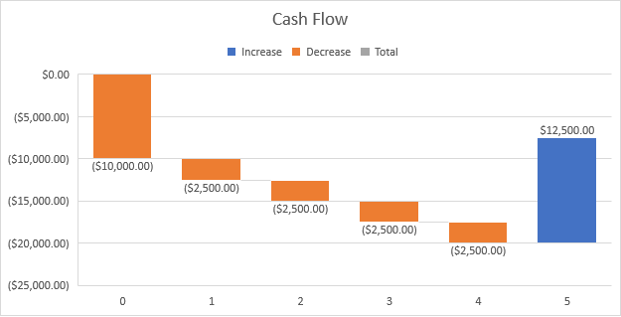

|  |  |  |  |  |
| --- | --- | --- | --- | --- |
| Saving money, without race car | |  |  |  |
|  |  |  |  |  |
|  |  |  |  |  |
|  | Year | Expenses | Profits | Cash Flow |
|  | 0 | $10,000.00 | $0.00 | $10,000.00 |
|  | 1 | $3,000.00 | $0.00 | $3,000.00 |
|  | 2 | $3,000.00 | $0.00 | $3,000.00 |
|  | 3 | $3,000.00 | $0.00 | $3,000.00 |
|  | 4 | $3,000.00 | $0.00 | $3,000.00 |
|  | 5 | $3,000.00 | $0.00 | $3,000.00 |
|  |  |  |  |  |
|  | ROR | #NUM! |  |  |
|  | Total | $25,000.00 |  |  |

